Motor Block

For this robot design, we need work out a system to compactly store our drive motors. This is because our robot design requires a relatively large section of the robot in the front to be empty so we can fit our claw/mobile in it. This means that we will not be able to directly put 1:1 motors on our wheels and instead must use a chain drive system. Because of this we need to find a way to pack 6 motors in the back half of our robot.

For this problem we came up with two different design on how to effectively solve the problem of needing to fix 6 drive motors in the back of the robot.

## Different design ideas

### Motor Block

### Vertical stack

This design revolves around the idea of tightly compacting 3 motors on each side of drive in a “block” with each motor touching the others. These blocks would be attached directly to the rear wheels which in turn would be attached to the rest on the wheels on a drive chain.

**Pros:**

* Strong
* Compact

**Cons:**

* Hard to access
* Little room for expanding

This design revolves around the idea of stacking 3 motors on each side on a tower above the back. The back wheel, front wheel and drive tower would then be attached on a chain in a triangle shape.

**Pros:**

* Unlimited space for expanding upwards
* Easy to access

**Cons:**

* Tower may end up being unstable causing drive problem

Between the two different designs we decided to go with motor block. This is because although the vertical stack has the advantages of being easy to access and having theoretically unlimited space to expand up the disadvantage of it being possibly unstable makes it inferior to the motor block. This is because the stability of the drive is extremely important as an unstable drive will not be efficient and will probably have the tendency to break apart. The motor block as has the advantage of being compact. This is a good trait for our design as we want to avoid the possibly of independent systems accidently interacting (I.e lift getting caught on the drive.)

**Choice:** Motor Block

Our next was to create a design for our motor block. We decided on doing a cad in inventor over doing a drawing as it is industry practice now days. No-one in the team knew how to cad so with the help of the internet and Riley from team 3116C we taught ourselves how to do it over a few weeks.

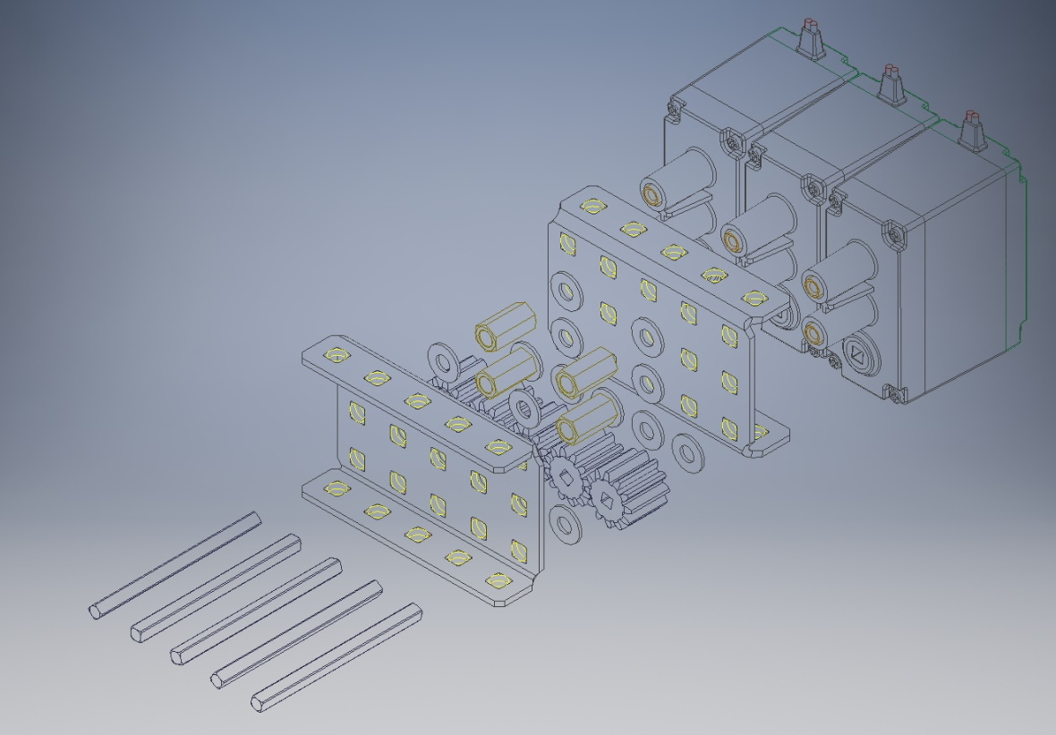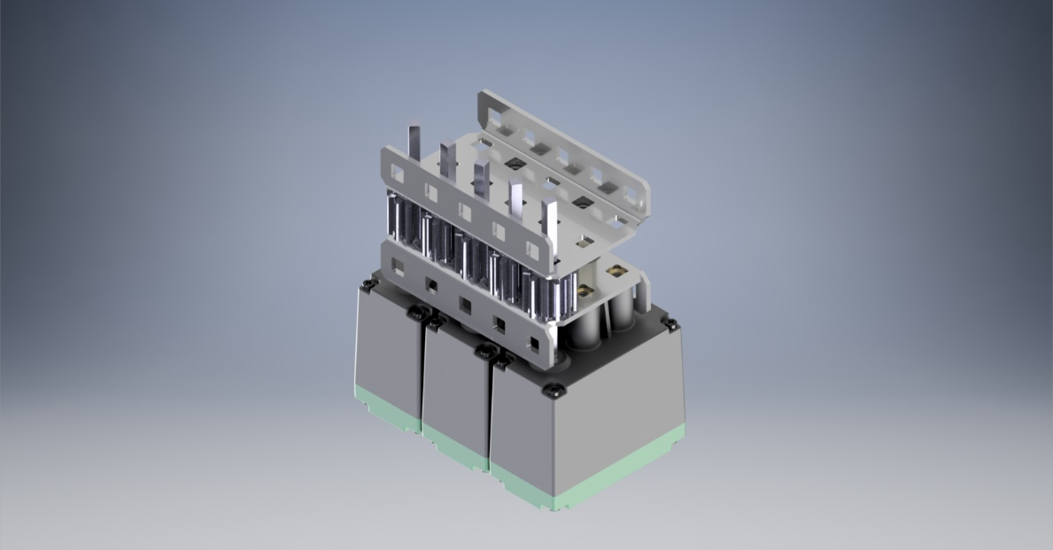

We are happy with the design above as we feel it fits all our criteria for to make a good drive train. It is compact, strong and efficiently. We made the render and exploded view in adobe inventor for which Autodesk had kindly given us a free licence last year at nationals. The render took 30 mins to finish and we decided to create an exploded view for this design so any team can easily build it if they choose too.

## Exploded view

## Render